**Exercise REST endpoint:**

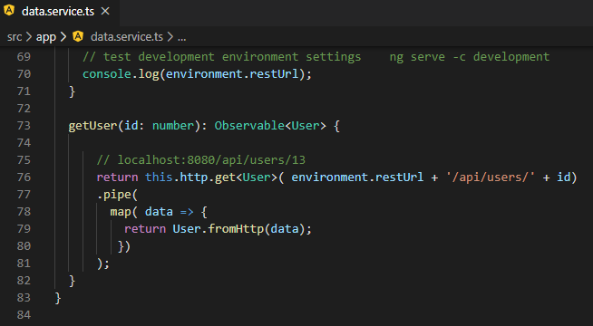

Implement getUsers()

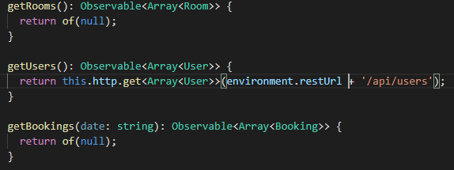

Test this for the rest retrieval of Matt:

Start the Spring boot application using the RoombookingApplication.java class and a RunAs application

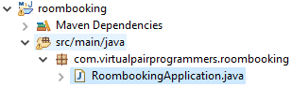

Open Brower Chrome with url:



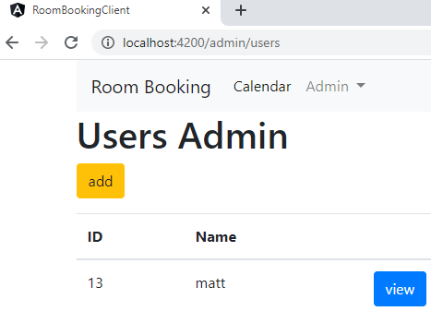

It works!

Now setup the preprocessing with the pipe method:

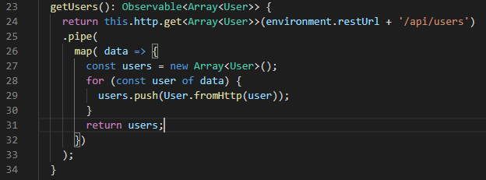

Make sure everything still works:

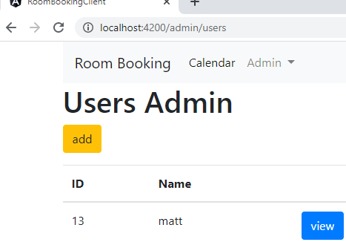

It still works!!

Let us now implement getRooms()

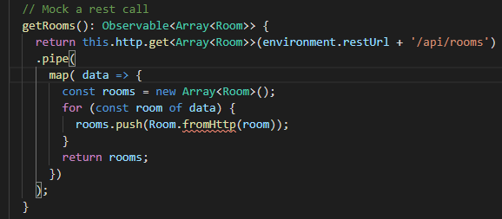

A compilation problem is indicating the need for a static fromHttp() for rooms

Go to Room.ts and fix this

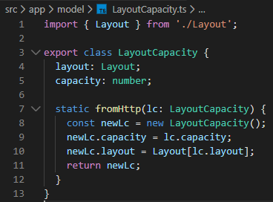

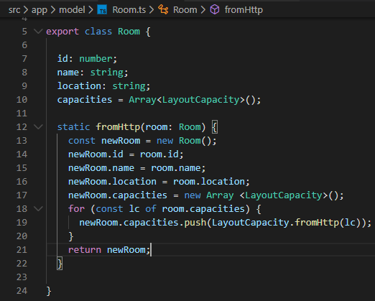

And so, the code compiles

Now, the written preprocessing works and test this with the console of no errors at the Url.

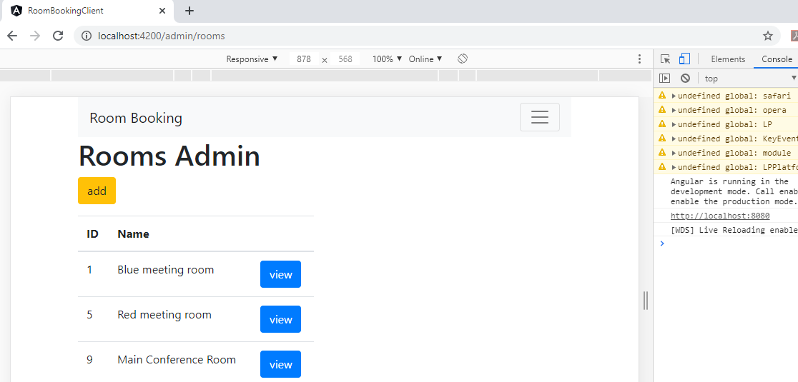

View works as well!!

